New Student Guide

GT Off-Road Racing | Data Acquisition

Andrew Hellrigel

03/2021

Table of Contents

1.0 Overview 2

1.1 Purpose 2

1.2 What is GT Off-Road 2

1.3 What is DAQ? 2

1.4 Purpose of DAQ 2

1.5 Steps to Join 2

1.6 Team Communication and Meetings 3

1.7 Note to Reader 3

2.0 Accessing Team Resources 4

2.1 Team Website/Wiki 4

2.2 Team Server File Structure and Access 4

2.3 GitHub File Structure and Access 4

2.4 Downloading and Accessing Team Software 4

2.5 Purchasing Guide 6

3.0 Next Steps / FAQ 7

3.1 What is the SCC? 7

3.2 Other Documentation to Read 7

4.0 Revision History 8

# 1.0 Overview

## 1.1 Purpose

The goal of this document is to provide new students on the GT Off-Road data acquisition sub-team with context on what GT Off-Road is as an organization and data acquisition’s role within that. New students aren’t expected to have any specific knowledge when joining the team, but if there is anything that is unclear or conflicting in this document or any referenced documents, the student should clarify the information with his/her sub-team lead.

## 1.2 What is GT Off-Road

GT Off-Road is a student organization whose primary goal is to design a prototype off-road racing vehicle to compete against other colleges in various static and dynamic events in BAJA SAE. For more information, visit the official BAJA SAE website: <https://www.bajasae.net/>.

## 1.3 What is DAQ?

Data Acquisition (DAQ) is a sub-team within GT Off-Road. DAQ handles pretty much everything that is electrical/software that goes on the car and also does experiment design and creates the necessary equipment to carry out experiments. This includes a variety of tasks. We design custom software to analyze data in real time that is flexible to be used with all of our systems. We develop various testing rigs to characterize components off of the car such as an engine dyno or shock dyno. We wire robust systems on the car such as the brake light, emergency stops, and a dashboard that have to fully waterproof and can withstand lots of vibration and harsh environments. We also create a data collection unit to go on the car during testing days.

## 1.4 Purpose of DAQ

The main goals of DAQ are to validate load cases use to design the car, and to validate our simulation model by collecting real world data so that we can run more accurate simulations.

Load cases are what the designers of the car use to decide how strong certain components of the car need to be so it is crucial to get the right load cases. Too small of a load case and the component will be too weak and will fail. Too large of a load case and the part will be overdesigned taking up unnecessary space and weight on the vehicle which reduces performance and increases costs.

Our simulation and vehicle dynamics team works to develop the load cases for parts that are extremely difficult to test in real life. However, in order to validate the physics and forces that their models experience, it is important to collect accurate data on what is simpler to measure in real life.

Our goal is then to design flexible systems that allow for running a wide range of tests on the car and to design the systems to be robust so that they can withstand the rigors of testing on an off-road vehicle with lots of shock and poor environmental conditions.

## 1.5 Steps to Join

To join GT Off-Road (and subsequently the DAQ team), you must join all of our communication channels, fill out an onboarding form, and pay team dues (usually it is like $30). Information about how to pay dues will be given in the #new-member channel on slack.

## 1.6 Team Communication and Meetings

**Slack**

Our team primarily communicates using Slack. To join the team slack, go to [gtor.slack.com](https://gtor.slack.com/) and create an account using your @gatech.edu account. Upon joining the workspace, hover over the word “Channels” on the left and a “+” should appear to add a channel. Join the #new-members channel and the #data_acquisition channels. It may also be helpful to install the desktop version of Slack and install the app.

You should also already be in the #general channel which is where important teamwide announcements are made. The #new-members channel is where you will find information about the onboarding form that must be completed, how to pay dues, and any new member training that is happening that may be interesting to attend. The #data_acquisition channel is the main channel that announcements are sent out on regarding sub-team meetings and updates.

Any questions that may arise should be sent in a direct message within Slack to the respective team lead for the data acquisition sub-team.

The SCC (student competition center) also has a slack that all team members need to join. This slack channel can be joined by going to <https://gatech.enterprise.slack.com/> and finding the slack page for the SCC.

**Microsoft Teams**

For virtual meetings, GT Off-Road uses Microsoft Teams. To be added to Microsoft Teams, send a direct message to the respective team lead for the data acquisition sub-team. Out team meetings (as of Spring 2021) are on **Tuesday/Thursday from 7:30pm-10pm and on Sunday from 4:00pm-7:00pm**. It is expected that members attend at least 2 of these meetings a week (a total of 5-6 hours per week) to be considered an active member of GT Off-Road. If this is a problem for any reason, it should be communicated to the sub-team lead and/or the team lead. Note that school should remain top priority and if there is an especially busy week, you should take the necessary time off to do well in your studies (assuming it has been communicated to the sub-team lead).

Meetings will be started in Teams by the sub-team lead at the respective times in the data acquisition channel on Teams. If there won’t be a meeting, or the time has changed for any reason, this will be communicated through the #data_acqusition channel on Slack.

Depending on health guidelines, etc. data acquisition team meetings may take place in person at the SCC as well. All of this information will be communicated through Slack.

**Discord**

For sub-team specific meetings and communications, the DAQ team has transitioned to Discord. Due to the growth of our sub-team and the need for a more stable communication and meeting method, a lot of the communication will occur on Discord. To be added to Discord, ask the sub-team lead and give them your Discord username. For the most part, it will be important to pay attention to the Announcements and General channel on Discord. And channels that don’t pertain to you can be muted if you wish. All updates about meetings will be communicated through Discord. If, for a sub-team meeting, we need to communicate with someone outside of our sub-team, then we will have the meeting on Microsoft Teams, but for the most part we prefer to meet on Discord because Teams uses a ton of computing resources and makes it difficult to really work on much else during the meetings.

If for any reason you can’t figure out where a meeting is and it wasn’t posted on Discord please send a direct message to the sub-team lead(s) so that they can communicate it properly. There are probably other team members in the same boat.

## 1.7 Note to Reader

Knowledge capture is critical to GT Off-Road’s longevity and continued success. As you read through this document and other documents that help get you up and running as a contributing member of our team, please take note of anything that inconsistent or any problems that you run into while joining our team. While we do our best to keep these documents updated, we often miss steps or things change, and so if you notice information that is outdated, please update it with the correct information or let the team lead or document author know so that the issue can be resolved appropriately. Thanks!

# 2.0 Accessing Team Resources

## 2.1 Team Website/Wiki

The team website and wiki can be found at <https://gtor.gtorg.gatech.edu/>. The SCC website and wiki can be found here: <https://www.sccgt.org/> and here: <https://sites.google.com/sccgt.org/sccwiki/home?authuser=0> respectively.

## 2.2 Team Server File Structure and Access

Most of the team’s files are stored on a network server that can be accessed by anyone on the team. To get the proper permissions to have access to the team’s network storage, the onboarding form must be filled out. Once the onboarding form has been filled out and processed (it can take up to 3-4 weeks to process), you can follow the instructions for joining the network server in Resources>NewStudents on the DAQ GitHub.

Most of the files that will be of interest will be in the folder called “Baja [year] (Current Season)”. In that folder there will likely be a folder for data acquisition. Most CAD files will be stored in the network drive in this location with a subfolder related to each project that is being worked on.

## 2.3 GitHub File Structure and Access

All software and PCB files are stored on data acquisition’s GitHub. To be added as a contributor to the repositories, ask the sub-team lead. There are a few main repositories. The DAQ repository is the main repository for PCB, electrical, embedded software, and project work. The GTOREagleLib repository is where our EAGLE library lives. The GTORDocumentation repository is where all project and general documentation should go. The GTORDaata repository is where software for the DAATA application is developed. This list may not be complete as more get added, but all the repositories can be found [here](https://github.com/Georgia-Tech-Off-Road). It is probably easiest to just bookmark our GitHub organization page to find all of the repositories easily.

The main repository is organized by project. High level projects are stored in a top-level folder whereas smaller projects are stored in the “Misc_Projects” folder. All hardware level libraries are stored in the “Libraries” folder. These are the libraries that are used to interact with all of our sensors and run on microcontrollers in C++.

The repository for our Eagle Library is used separately to avoid merge conflicts (because people working on different PCB’s generally are still interested in using some of the same components, or at the very least, adding to the same libraries). For instructions on how to use the team’s Eagle library, find the guide in Resources>NewStudents on the main GitHub.

If you have never used GitHub or Git before, it is recommended to start by using the GitKraken GUI. If you are familiar with using the CLI (command line interface) or another GUI for Git, you are more than welcome to use that. For tutorials on how to use Git, see: <https://www.gitkraken.com/learn/git/tutorials>.

## 2.4 Downloading and Accessing Team Software

**Microsoft Teams Download**

To download Microsoft Teams on Windows (should also work for Linux/Mac), go to <https://www.microsoft.com/en-us/microsoft-teams/download-app> and install for desktop.

**Slack Download**

To download slack for Windows, go to <https://slack.com/downloads/windows> and click download. For Linux go to <https://slack.com/downloads/linux> and for Mac go to <https://slack.com/downloads/mac>.

**Discord Download**

To download and install Discord, go to <https://discord.com/download>.

**Eagle Download**

To install Eagle, first get educational access to Autodesk products [here](https://www.autodesk.com/education/edu-software/overview?_ga=2.132789582.1533660205.1618200898-1990998181.1614128526&sorting=featured&page=1). Then, download Eagle [here](https://www.autodesk.com/products/eagle/free-download?plc=F360&term=1-YEAR&support=ADVANCED&quantity=1) and log in using the same credentials that were used to get educational access to Autodesk products.

**Git/Git Bash Download**

To install Git/Git Bash go to <https://git-scm.com/downloads> and find the appropriate download for your machine.

**GitKraken Download**

To install the professional version of GitKraken, get the GitHub student developer pack here: <https://education.github.com/pack>. Then install Gitkraken here: [https://www.gitkraken.com/download](https://www.gitkraken.com/download%20) and use the same credentials that were used to get the GitHub student developer pack to automatically get all of the Pro features.

**Arduino/Teensyduino Download**

Arduino and the Arduino IDE can be found here: <https://www.arduino.cc/en/software>. The installation for Teensyduino can be found here: <https://www.pjrc.com/teensy/td_download.html>.

**Python Download**

Our team uses Python 3.6.8. The download for this can be found here: <https://www.python.org/downloads/release/python-368/>.

**PyCharm Download**

Directions for installing PyCharm can be found here: <https://www.jetbrains.com/help/pycharm/installation-guide.html>.

**Visual Studio Download**

The link to install Visual Studio can be found here: <https://visualstudio.microsoft.com/downloads/>.

**Solidworks Download**

To install Solidworks, go to <http://software.oit.gatech.edu/> and click the “Download Software” Link. In the drop-down boxes select software type as “Microsoft Windows Desktop” and affiliation as “Students”. Then find Solidworks in the list of software, click “Request Software”, and then follow the directions for installation. Note that Solidworks is only available to install on Windows.

**MATLAB Download**

To install MATLAB, go to <http://software.oit.gatech.edu/> and click the “Download Software” Link. In the drop-down boxes select software type to match your computer (i.e. Windows, Linux, Max, etc.) and affiliation as “Students”. Then find MATLAB in the list of software, click “Request Software”, and then follow the directions for installation.

**Fusion 360 Download**

To install Fusion 360, first get educational access to Autodesk products [here](https://www.autodesk.com/education/edu-software/overview?_ga=2.132789582.1533660205.1618200898-1990998181.1614128526&sorting=featured&page=1). Then, download Fusion 360 on the same website by finding Fusion 360 in the list of software offered.

## 2.5 Purchasing Guide

All purchasing/ordering can be done through the team’s purchasing spreadsheet. All fields need to be filled out for each item that is requested. The requesting is done on the tab with “FY[year] TBP” (to be purchased). Most likely, “Data Acquisition” will be selected as the subsystem and to find the line item to purchase under, it will most likely be the line item associated with data acquisition hardware (see the spreadsheet tab labeled “Total FY [year]”. If there is any confusion about what line item to select, ask the sub-team lead. Read the tab labeled “Purchasing Guidelines” before filling out orders as well.

It typically takes ~48 hours to get orders approved (this can be accelerated by reaching out to the financial lead for approval. After that it can take anywhere from a day to a week for orders to be placed. It is crucial to plan to make sure that orders can be placed in a timeframe that makes sense. Orders are prioritized based on the “Need By Date” Column so make sure this is filled out to a date that makes sense.

**Links to Purchasing Spreadsheets**

[Purchasing Spreadsheet FY20](https://docs.google.com/spreadsheets/d/1ILN35p0WuqsaUOu9AnwBnsDROKAHuUL8cqE_y23wues/edit#gid=1002179389)

[Purchasing Spreadsheet FY21](https://docs.google.com/spreadsheets/d/18rTWA8Tcduktc77QBWXiJfMwBkiPgNHR7hwQoL3IraQ/edit#gid=1937511476)

# 3.0 Next Steps / FAQ

## 3.1 What is the SCC?

The SCC (Student Competition Center) is where our shop space is. It is located at [575 14th St NW, Atlanta, GA 30318](https://www.google.com/maps/place/Georgia+Tech+Student+Competition+Center/@33.7867154,-84.4070362,18z/data=!4m5!3m4!1s0x88f504f20314d3f7:0x392652b162d2d35e!8m2!3d33.7870186!4d-84.4067385).

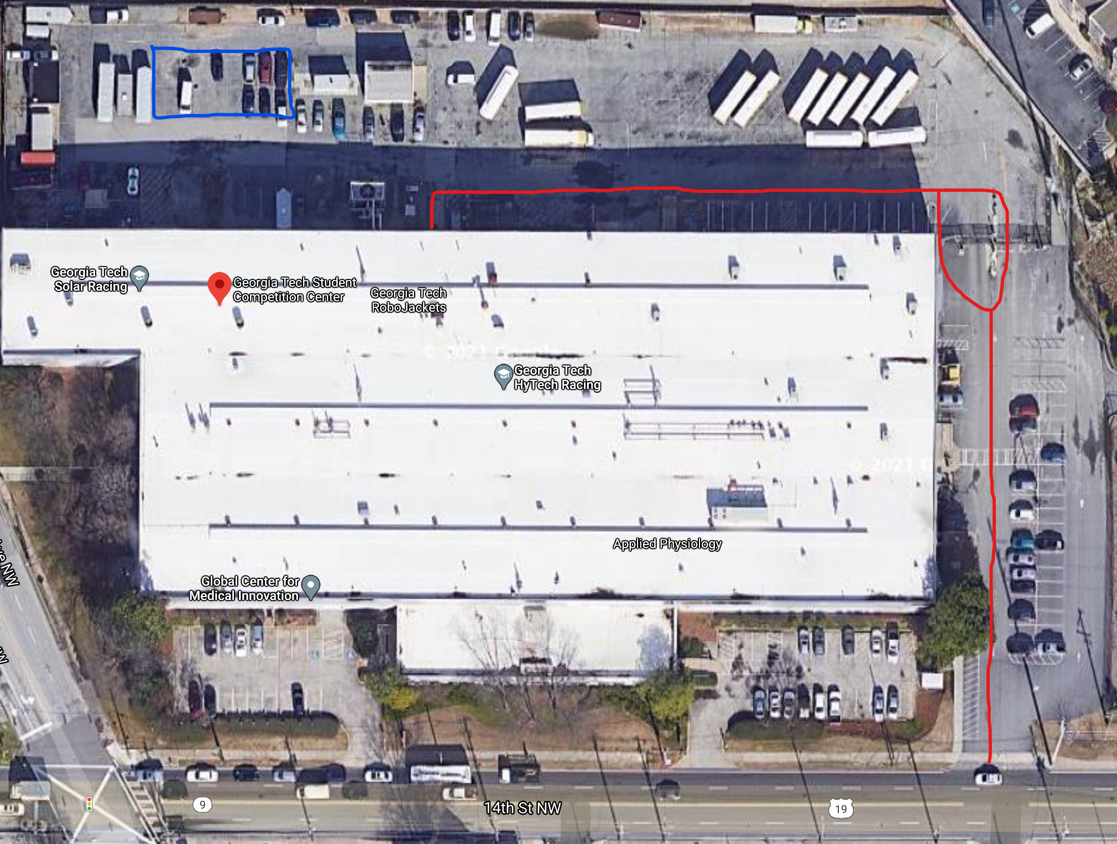

The SCC can be accessed through the drive through gate or the walk in gate in the top right (requires Buzzcard access that is received through filling out the onboarding form). The area outlined in blue is generally the best place to park. The entrance to the building is the door on the backside of the building which is where the red line leads to. Our shop space (along with some other student teams) is the first door on the right immediately after walking in to the building (also requires Buzzcard access).

The green route bus will take you directly to the SCC from campus if you don’t have any method of transportation. Alternatively, you can post a message in #ride-share on slack to see if anyone would be willing to give you a ride. The app called “GT Portal” can be used to see what busses are active and where they are located, along with the different routes that they take.

## 3.2 Other Documentation to Read

Depending on what types of projects you are interested in doing, there is more application specific documentation in the electrical, mechanical, and software documentation folders on the GitHub. There is also some interesting content in the Misc. Documentation folder if you are interested in learning about some projects our team members have worked on in the past or if you want to view any presentations our team members have given in the past.

# 4.0 Revision History

03/24/2021 (Andrew Hellrigel) – Created new student guide and topics to be covered.

04/12/2021 (Andrew Hellrigel) – Finished first revision of the guide for students that are joining for the spring/summer semester of 2021.

06/18/2021 (Andrew Hellrigel) – Added the note to reader (section 1.7); updated GitHub section to reflect changes in GitHub structure; updated communication to reflect new use of Discord.